INTRODUCTION
We are a group of 11 people and our aim is to organize the Jamborette, which is a camp for scouts, in the campus of Middle East Technical University. The important thing is that we have only 10 weeks to plan the camp, therefore we should well organized. This is our first report showing our organizational structure, mission, vision and strategies. At the end of the report a Gantt Chart indicating the schedule of the project.

OUR MISSION

The mission of the first Jumbur Jemaatte –Jamborette Organization Team- is taking a firts step into contribution of the mission of the scouting by METU Jamborette stated by ‘World Organization of the Scout Movement’ below:

“The mission of Scouting is to contribute to the education of young people, through a value system
Based on the Scout Promise and Law, to help build a better world where people are self-fulfilled as
Individuals and play a constructive role in society.”

Moreover the team aims to introduce “Turkish Culture” and Turkey for the group of scouts from all over the world. Unity, improving relationship and partnership are among the challenges to deal with.

OUR VISION

Jumbur Jemaatte Jamborette group will take bigger steps to improve scouting activities throughout the world and attract people in Turkey for scouting as well.

We see scouting as dynamic, influential and potentially attracting people in all cultures.
We see METU Jamborette as a milestone for the spread of scouting in Turkey.
We see Jamborette organization attracting adults in Turkey as for scouting.
We see the Jamborette a chance to provide youth with increasing experiences appropriate to
level; and opportunities for leadership

We see the METU Jamborette as an opportunity to involve the community in supporting

Jumbur Jemeatte will meet the needs of young people without regard to race, economic status etc. providing them the opportunity to develop character, citizenship, personal fitness, teamwork and leadership skills.

MEETING REPORT

Our group has had some meetings and decided on following issues:

- Some sub-groups will be formed, details of which are explained below. There will be a chief of every sub-group and a manager will manage the whole group. See Figure 1 for the organizational chart of our group.

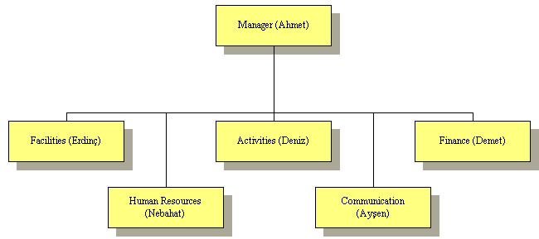
Figure 1. Organizational chart

- The whole group of 11 people will meet every two weeks. The sub-groups will meet more frequently and will be on continuous contact.

- A schedule is formed based on the pre-research results. The Gantt representation of the schedule is enclosed. Details of jobs and the sub-groups responsible are given below.

DETAILS OF THE JOBS

Accommodation:
  - Campsite determination
  - Toilets, bathrooms
  - Electricity, water
  - Healthcare
  - Security
  - Communication
  - Disposal
  - Nourishment
  - Souvenir
  - Bank
  - Greeting and transportation
  - Construction needs and labor contracts of the all above

Activities:
  - Date/Time
  - Place
  - Transportation
  - Content
  - Permissions
  - Construction needs and labor contracts of activities

Finance:
  - Accommodation costs
  - Activity costs
  - Announcement costs
  - Labor costs
  - Relations with sponsors

RESPONSIBILITIES AND MEMBERS OF SUB-GROUPS

First mentioned member is the chief of the sub-group.

Manager: (Ahmet)
Responsible of the whole camp. Responsible of facilitating communication among sub-groups. Responsible of smoothening the process. Responsible of representing the group in front of other people.

Facilities: (Erdinç, Ayşe, Murtaza, Yiğitcan)
Responsible of all matters related to facilities, such as:
  - Campsite analysis
  - Layout
  - Cleaning needs
  - Food
  - Accommodation
  - Supplies
  - Utilities

Activities: (Deniz, Seda)
Responsible of all matters related to activities, such as:
  - Scheduling
  - Permissions
  - Organization, contracts

Finance: (Demet, Mehmet)
Responsible of all matters related to finance, such as:
  - Budgeting, accounting
  - Payments
  - Transactions at the camp
  - Relations with sponsors

Human Resources: (Nebahat)
Responsible of all matters related to human resources, such as:
  - Security labor
  - Cleaning labor
  - Healthcare labor
  - Shopping labor
  - Others

Communication: (Ayşen)
Responsible of all matters related to communication, such as:
  - Announcement of the camp
  - Relations with media
  - Preparation of printed material
  - Preparation of the Internet page
  - Preparation of the daily newspaper and daily internet bulletin during the camp

Project Schedule – Gantt Chart

Jobs
Jobs |  |  |  |  |  |  |  |  |  | Announcement
Jobs | Financial Calculations, Sponsor Search
Jobs |  |  |  |  |  |  | Labor Contracts
Jobs |  | Activity Planning, Permissions etc.
Jobs |  | Construction Planning |  |  |  |  |  |  |  |  |  |  |  | Constructions
Jobs | Campsite Analysis
Jobs | 1 | 2 | 3 | 4 | 5 | 6 | 7 | 8 | 9 | 10 |  |  |  | Spring '04
 | Weeks

The chief of every sub-group is responsible of the timeliness and health of the related activity. In that, the following relations should hold:

Mission Sub-group
Campsite Analysis Facilities
Construction Planning Facilities
Activity Planning Activities
Mission Sub-group
Labor Contracts Human Resources
Financial Calculations Finance
Announcement Communication

http://www.scout.org/strat/missen.shtml

